

**A Project Report on**

**BARBIE WITH BRAINS PROJECT**

**Submitted to the**

**Ms. Ashwairya**

(Python Project)

By

**Ayush Diggiwal**

**Shubham Shirod**

**Swapnil sahu**

**INTRODUCTION**

This paper introduces the world-famous doll, Barbie, which served the purpose of just being trivial, but the improvised version of the Barbie, which is designed to provide kids with hours of entertainment, functionality and productivity enhancements. This is a great way to incorporate and guide the kids to learn and to witness the beauty of technology right from their hand-held toys in one’s childhood. The Barbie is designed to be a kid’s teacher, comforter, and guider, take career, to be solicitous, observer and a good friend. One of the profitable applications of this Barbie, in the lives of children is for the education purposes. The Barbie is coded with innumerable education related content and topics, when the kid needs help regarding his/her doubts in homework, they can completely depend on the Barbie’s brains for the perfect answer to be delivered. There is no limit for Barbie’s extraordinary memory, as it extends to leaps and bounds. This feature not only is limited to schooling, but also helps the children to identify and unveil their passion towards the subject; they can start diving deep into their favourite topics with the help of Barbie’s brains. Thus, finding new interesting path for their career. This feature comes handy anytime and anywhere as the kid wishes. The ability that makes this Barbie a real time natural human friend to children or any other person in a usual way is it greets them politely, calls them out by their names and start conversations. Barbie can engage in some approaching conversations by listening to users and generating intelligent responses to their queries. This feature fills the opposite person who is interacting with the Barbie with enthusiasm, making the listener feel more interested and appealing to the Barbie, developing a friendly relationship among them.

**OBJECTIVE**

The rapid growth of modern-day technology has paved way for innovative ideas, one of them is presented in this paper, which is “Barbie with Brains”. This Barbie is contradictory to the other dolls which stays idle, perhaps interacts with humans especially kids, just like any typical person would do. This interactive Barbie becomes more charismatic with its breathtaking features, like Barbie itself being a knowledge hub for education purposes, which benefits children in their schooling and learning, where sometimes there is no need of any knowledge or teaching backup, while Barbie is around. It will response on the calling and perform action. It will be useful for user who are abnormal and handicap as it will react on voice and do the work for user.

# 

**BACKGROUND**

Visual Studio Code also commonly referred to as VS Code, is a source-code editor made by Microsoft with the Electron Framework, for Windows, Linux and MacOS. Features include support for debugging, syntax highlighting, intelligent code completion, snippets, code refactoring, and embedded Git.

A python package is a collection of modules. Modules that are related to each other are mainly put in the same package. When a module from an external package is required in a program, that package can be imported and its modules can be put to use. Python IDLE offers a full-fledged file editor, which gives you the ability to write and execute Python programs from within this program. The built-in file editor also includes several features, like code completion and automatic indentation, which will speed up your coding workflow.

**HARDWARE AND SOFTWARE**

**REQUIREMENTS**

**Software Requirements**

|  |  |
| --- | --- |
| **Back-End** | **Front-End** |
| Python | N/A |
| Visual Studio Code |  |

**Hardware Requirements**

|  |  |
| --- | --- |
| Operating System | Window 7 or above |
| Processor | Intel core i5 and later |
| Disc Space/RAM | 4 GB or above |

**CODING**

import pyttsx3

import datetime

import speech_recognition as sr

import webbrowser

import wikipedia

import random

import os

import smtplib

engine = pyttsx3.init('sapi5')

voices = engine.getProperty('voices')

#print(voices[0].id)

engine.setProperty('voice', voices[0].id)

def speak(audio):

engine.say(audio)

engine.runAndWait()

def wishMe():

hour = int(datetime.datetime.now().hour)

if hour>=4 and hour<12:

speak("Good Morning!")

elif hour>=12 and hour<18:

speak("Good Afternoon!")

elif hour>=18 and hour<23:

speak("Good Evening!")

else:

speak("Its late sir, but I am here.")

speak("my name is Alpha. Please tell me how can I help you sir")

def takeCommand():

#its takes mic input and returns string output

r = sr.Recognizer()

with sr.Microphone() as source:

print("Listening...")

r.pause_threshold = 1

r.energy_threshold = 100

r.adjust_for_ambient_noise(source, duration = 1)

audio = r.listen(source)

try:

print("Recognizing...")

query = r.recognize_google(audio, language='en-in')

print(f"User said: {query}\n")

except Exception as e:

#print(e)

print("Say that again please...")

speak("Sorry, I could not get that")

return "None"

return query

def sendEmail(to, content):

server = smtplib.SMTP('smtp.gmail.com', 587)

server.ehlo()

server.starttls()

server.login('YourEmail@mail.com', 'YourPassword')

server.sendmail('YourEmail@mail.com', to, content)

server.close()

def alphabetss():

alphabets = ['a', 'b', 'c', 'd', 'e', 'f', 'g', 'h', 'i', 'j', 'k', 'l', 'm', 'n', 'o', 'p', 'q', 'r', 's', 't', 'u', 'v', 'w', 'x', 'y', 'z']

speak("Repeat after me")

speak(alphabets)

speak("once again one by one")

for i in alphabets:

speak(i)

aaaa = takeCommand().lower()

while(aaaa!=i):

speak("Try Again")

aaaa = takeCommand().lower()

speak("very good")

if 'stop' in aaaa:

break

def ludo():

speak("Ludo mode activated, say 'roll' to roll the dice over, and 'exit' to stop ludo mode")

dice = takeCommand().lower()

while 'exit' not in dice:

if 'throw' or 'roll' in dice:

speak("trrr")

rr = random.randrange(1,7,1)

speak(rr)

else:

continue

speak("exit")

if __name__ == "__main__":

wishMe()

while True:

query = takeCommand().lower()

#logic for executing tasks based on query

if 'wikipedia' in query:

query = query.replace("wikipedia", "")

results = wikipedia.summary(query, sentences=2)

speak("According to wikipedia")

print(results)

speak(result)

#elif 'alphabets' or 'alphabet' in query:

#alphabetss()

elif 'youtube' in query:

webbrowser.open("youtube.com")

elif 'google' in query:

webbrowser.open("google.com")

elif 'code' in query:

speak("Do you want to code online or offline, sir?")

newquery = takeCommand().lower()

if 'online' in newquery:

speak("Where do you want to code sir, Hackerrank or code chef")

newquery1 = takeCommand().lower()

if 'hackerrank' in newquery1:

webbrowser.open("hackerrank.com")

elif 'codechef' in newquery1:

webbrowser.open("codechef.com")

elif 'offline' in newquery:

speak("Visual Studio, Android Studio, Unity, or Sublime")

newquery2 = takeCommand().lower()

if 'android' in newquery2:

andpath = "C:\\Program Files\\Android\\Android Studio\\bin\\studio64.exe"

os.startfile(andpath)

elif 'visual' in newquery2:

vispath = "C:\\Users\\Maverick\\AppData\\Local\\Programs\\Microsoft VS Code\\Code.exe"

os.startfile(vispath)

elif 'sublime' in newquery2:

subpath = "C:\\Program Files\\Sublime Text 3\\sublime_text.exe"

os.startfile(subpath)

elif 'unity' in newquery2:

unipath = "C:\\Program Files\\Unity\\Hub\\Editor\\2019.3.9f1\\Editor\\Unity.exe"

os.startfile(unipath)

speak("Here you go sir")

elif 'play music' in query:

music_dir = 'D:\\songs'

songs = os.listdir(music_dir)

l = len(songs)

n = random.randrange(0,l,1)

os.startfile(os.path.join(music_dir, songs[n]))

elif 'time' in query:

strTime = datetime.datetime.now().strftime("%H:%M:%S")

speak(f"the time is {strTime} sir")

elif 'you' in query:

speak("My name is Alpha, speed 2 giga hertz, built by Samarth Ranjan at Ranjan Vision Labs. My full name is Artificially Intel Personal Home Assistant.")

elif 'who am i' in query:

speak("You are my creator sir. You have build me and I am here to help you as your virtual assistant")

elif 'creator' in query:

speak("Master Samarth Ranjan is my creator.")

elif 'purpose' in query:

speak('I have been developed to serve my assigned master as a virtual assistant. My name is Alpha')

elif 'suno' in query:

speak("haaan sir bo lee a")

elif 'send email' in query:

try:

speak("What should i say?")

content = takeCommand()

speak("Whom should i send this to?")

mailname = takeCommand().lower().replace(" ", "")

to = mailname+"@gmail.com"

print(to)

sendEmail(to, content)

speak("Email has been sent!")

except Exception as e:

speak("Sorry I could not get it, would you please repeat sir")

elif 'stop listening' or 'stop' in query:

c = random.randrange(0,2,1)

if c==0:

speak("I will wait for your command")

elif c==1:

speak("Ok sir")

break

**OUTPUT SCREENSHOTS**

* As a result, the following output will be displayed.

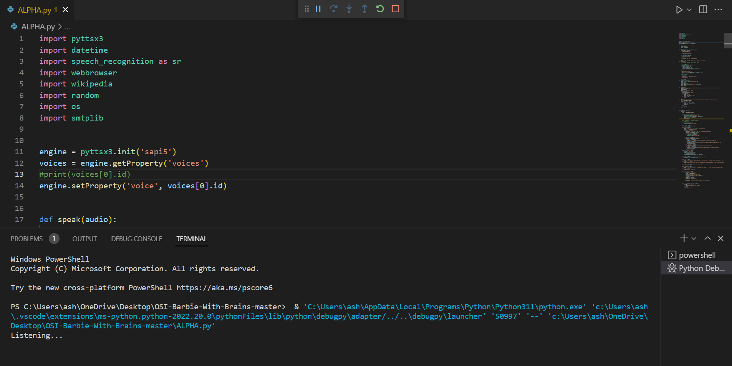

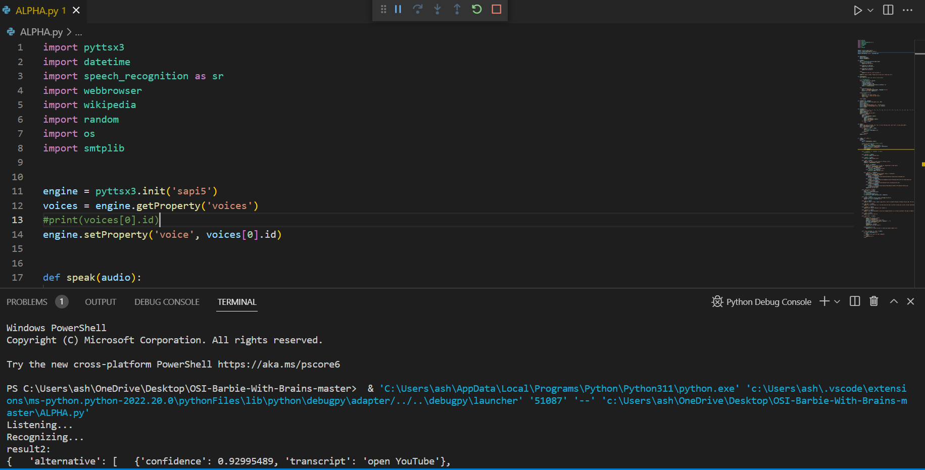

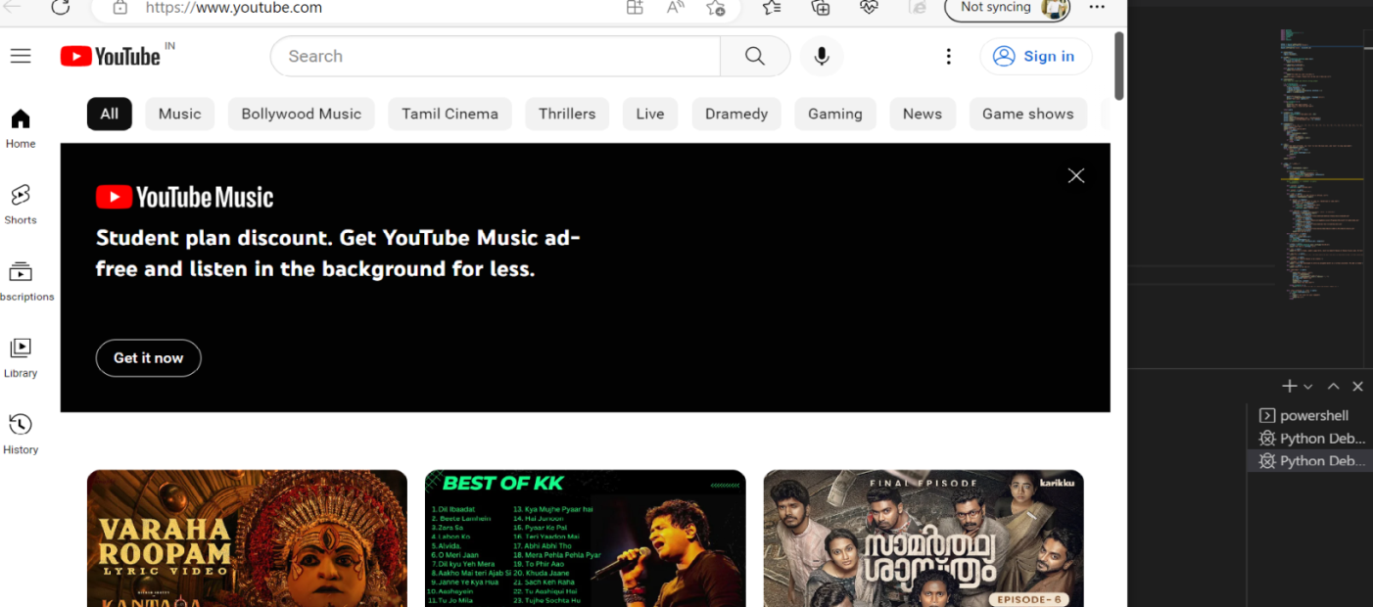

**FUTURE ENHANCEMENT**

The future of voice command assistant is looking bright. Given its current global usage both in the home and on the move, it seems as though this technology will only get bigger over the next few years. According to Google, 20% of queries on Google’s mobile app and Android devices are voice searches, and the number is expected to grow exponentially. Google’s voice assistant is now available on more than 400 million devices. As we continue to navigate contactless human interaction during COVID-19, voice enabled tech plays an integral role in those advancements. Voice recognition assistants are capable of more than just answering your queries for Google. Thanks to technical due diligence investment, software engineers and developers can continue growing the technology. More applications are being made specifically to be compatible with smart devices, such as smart household appliances.

**CONCLUSION**

Robotic technology is rapidly evolving into the 21st century. The usage and its wide applications have become a part of day to day lives of the society. Robotic technology can be found in stores, hospitals, shopping malls, homes, restaurants, work places and battle fields. But this “Barbie with Brains” is a breathtaking breakthrough where the user as younger generation gets to see the future world with a simple. This Barbie can tremendously indulge in kid’s life starting from education purpose to child’s safety. Robots like this can response on human’s voice and recognize the need and perform action on it. It will make work more easy and sufficient and faster.

**REFERENCES**

* Code.visualstudio.com used for running code.
* geeksforgeeks.org/python-packages/ used for importing packages.
* Citefactor.org for Research Paper.